March 3, 2021

Groton Planning Board
Town Hall
Groton, MA 01450

RE: Village at Shepley Hill

Dear Takashi and Members of the Planning Board,

This letter, relative to the Village at Shepley Hill Definitive Subdivision, supplements previous letters sent or copied to the Planning Board and Conservation Commission dated December 14, 2020, January 4, 2021, and February 8. 2021. This letter is primarily in response to Bullet Point Number 3 of a submission by the applicant arguing that the property possesses 'unusual' topographic features and therefore should be granted a waiver for excessive fills.

I would like to first reiterate that I very much appreciate the significant efforts the applicant has made to address environmental issues that have been raised with respect to the proposed development. The fact that many hundreds of feet of roadway with fills of 7 to more than 30 feet as well as several hundred feet of retaining wall within 50 feet of wetlands still remain despite those efforts speaks to the fact that the development itself does not fit on this property.

The applicant's Bullet Point Number 3 argument is quoted below. I believe this statement not only demonstrates that the applicant is unfamiliar with Groton's natural environment but also provides the basis of why a waiver must not be granted.
3. "THE PROPERTY POSSESES UNUSUAL TOPOGRAPHIC FEATURES - The assessment of what constitutes unusual “topographical” features requires a multidimensional evaluation.
While many other properties in Groton have drumlins and other various glacial land forms, the Property has significant physical features that most other properties do not share. The drumlin is located in the center of the western uplands of the Property that can only be accessed by crossing an onsite intermittent stream. The onsite wetlands not only bifurcate the property into 2 large upland areas but also run along the entire perimeter of the Property making access impossible without crossing a wetland. In order to gain access to the upland areas, it is necessary to not only cross two intermittent streams but also to fill areas that are proximate to the wetland areas in order to create safe passage along the roadways in accordance with best engineering practices and the design requirements of Groton’s Subdivision Rules and Regulations."
Attached to this letter is a portion of a GIS map showing the central portion of Groton, including the area of the proposed development. The map shows the terrain in a general manner as well as streams, wetlands and certified and potential vernal pools. The data used for the GIS map somewhat underestimates the extent of wetlands and streams. For example, the extent of wetlands shown on the GIS map for this property is less than what is shown on the proposed development plans.

Based on the GIS map, the pattern of wetlands and streams in this area of Groton is clear. Every drumlin hill, as well as other significant topographic features, is largely surrounded by wetlands or streams. The pattern and high number of these features in Groton is not a coincidence. It is the result of Groton's geologic history and it is the core reason for the extraordinary environmental value of this area.

This property lies at the heart of the Petapawag Area of Critical Environmental Concern. The introduction to the nomination documentation that resulted in State Designation notes the following:

"The Squannassit / Petapawag area contains one of the most remarkable concentrations and varieties of glacial landforms in New England: a multiple-form drumlin swarm; extensive areas of eskers, kames and kettles; broad ground moraines; areas scraped bare by the glacier; and the remnants of an enormous glacial lake with hanging deltas where streams flowed in and valleys where great, but short-lived, rivers flowed out. The drumlin swarm is one of the most sculptural topographic forms that can be found anywhere.

This complex set of landforms has left both complex topography and soils. The intricate scale of the landforms results from rapid changes in degree and orientation of slope across the landscape. The types of soils in the various landforms also vary rapidly from place to place. ....... The array of glacial landforms across the Squannassit / Petapawag region also resulted in complex hydrologic systems. Natural drainageways were, in many places, blocked by the landforms, resulting either in torturous flow paths for streams, or in swamps.

The ecology of the Squannassit and Petapawag nomination areas reflects the unusual diversity of these landscape elements. The swamps and intricate systems of streams lie in combination with diversity of soils and topography. Overlaid on this is a unique diversity of vegetation which has in turn been amplified by the topography and soils. This confluence of diversity has resulted in a great variety of habitat types and consequent richness of wildlife, including major concentrations of rare and endangered species. The diverse ecology of this region is the product of these special landforms, water systems, and vegetation, combined with a human history which has left the integrity of this landscape still intact."

The combination of wetlands, streams and a steep glacial landform, such as exist on this property, may be unusual in other towns or regions, but it is definitively not unusual in Groton. The combination is, however, critical to the functioning of the ecosystem in this area.

Over the past forty years, Groton has established a set of successful local regulations aimed at protecting the fragile ecosystem and extraordinary landscape of our town. These controls are balanced by other regulations, such as our Flexible Development Bylaw, that create options for developing land without major impact. Groton is currently facing increasing development pressure, in part because of the success of our regulations in protecting the character of our town. Development pressure is likely to increase further when the Indian Hill Music Center opens and increased numbers of people become aware of what Groton has to offer.

If the Board grants a waiver for the massive exceedance of the cut and fill regulation, the only purpose of which is to allow the applicant to develop more lots than are possible on this property without a waiver, that critical regulation will become unenforceable for future development proposals and other fragile lands in Groton will become developable.

I would also like to note that issues such as this should have been dealt with at the Preliminary Plan stage of permitting, but at that time the applicant indicated that waivers were not required for this development. When I walked the property with the applicant on October 10th, there was mention that large cuts and fills were required to construct the roads. When I asked how they were dealing with the cut and fill regulation, they indicated they were not aware of those limitations. The applicant then chose to continue with the permitting process, knowing there was significant risk to approval. The situation the applicant currently faces is a combination of an oversight and ensuing choices. The Board must not be influenced to grant such a serious waiver based on the combination of expense and a valid attempt to deal with unresolvable physical conditions on this property.

Respectfully,
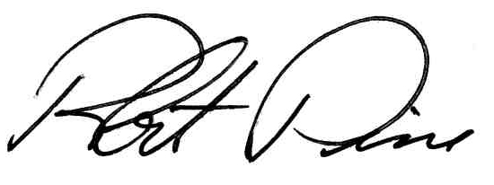
Robert Pine, PE FASLA

cc. Shepley Hill Capital Partners, LLC
Groton Conservation Trust

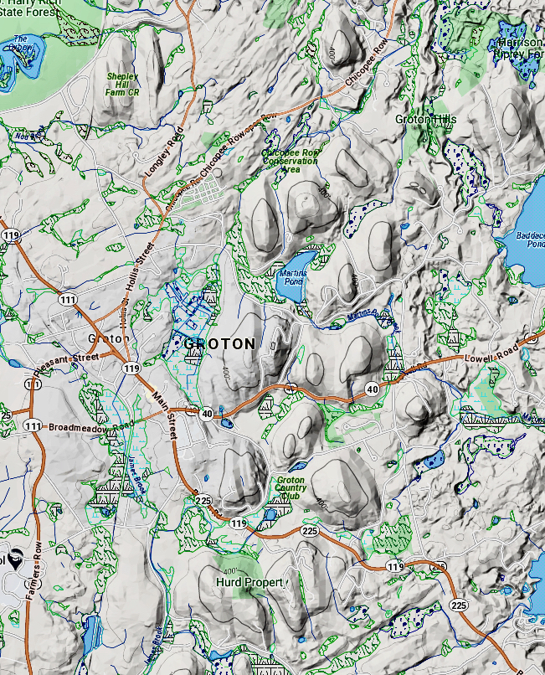
Project Location

